**Skill Test (B) – HTML/CSS/Javascript**

|  |  |
| --- | --- |
| Name | Esther Su |
| Date | Dec 22 |

The HTML/CSS and JavaScript test is used to assess candidates knowledge of HTML, CSS and JavaScript as well as their ability to utilize JavaScript to manipulate Document Object Model built from HTML and CSS. A good front-end developer should be able to utilize all these technologies to create a modern, dynamic, and interactive user interface.

Below is a screenshot of a web page which you need to design using HTML/CSS/Javascript.

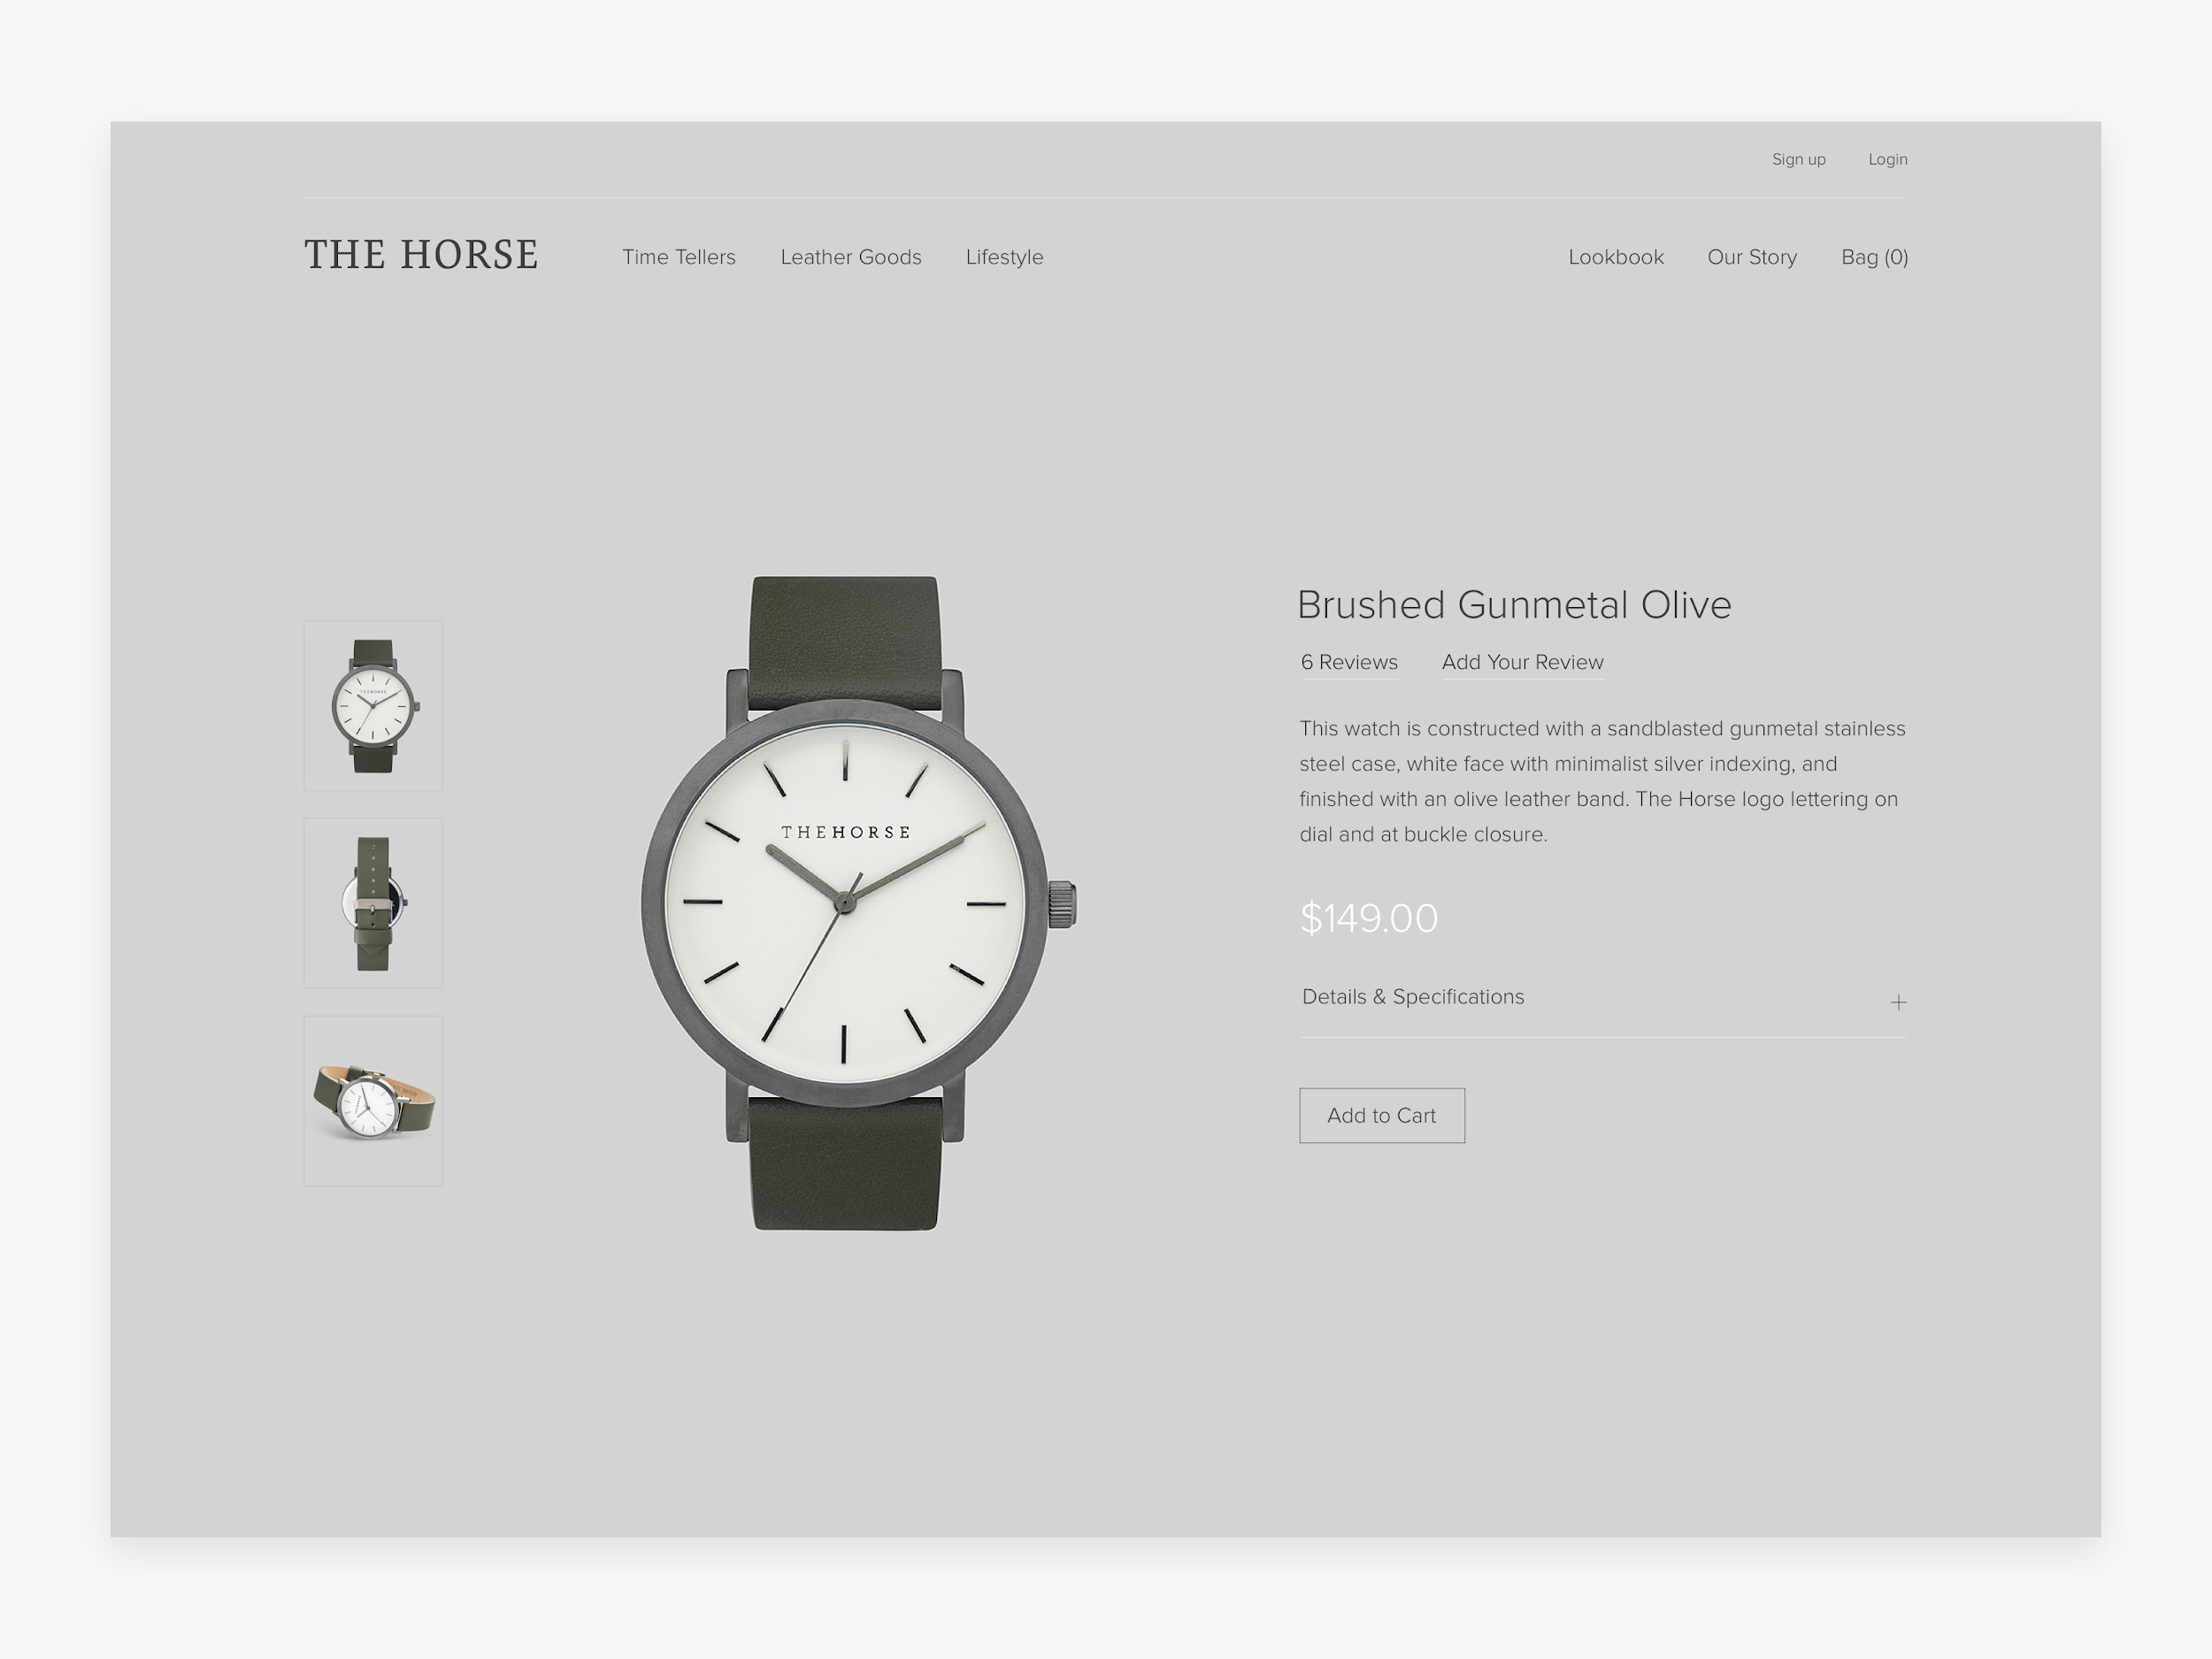

Send us the files with your finished work. You can share your files via github / google drive / dropbox